DIGITAL SCHOOL CONTACTS

1. EXECUTIVE DEAN- DIGITAL SCHOOL
dean-dsvol@ku.ac.ke - 0719739438/
- 020-870-3288

2. COORDINATOR, TEACHING
& QUALITY ASSURANCE
ddteaching-digitalschool@ku.ac.ke- 0717502496/
- 020-870-4096
3. COORDINATOR,
EXAMINATIONS - 0736-244-464/
dsvolcoord-exams@ku.ac.ke - 020-870-3292

4. CO-ORDINATOR,
CONTENT DEVELOPMENT- 0719-739-445/
ddcontent-digital@ku.ac.ke 020-870-4236

5. COORDINATOR, 0708649560/
CONTINUING EDUCATION 0208704275
PROGRAMME
dsvolcoord-cep@ku.ac.ke

6. COORDINATOR, - 0794697208
E-Learning
coordinator-elearning@ku.ac.ke - 020-870-3198

7. Chat@ku.ac.ke

8. Ticket: support.ku.ac.ke



KENYATTA UNIVERSITY
DIGITAL SCHOOL
VIRTUAL ORIENTATION AND TRAINING PROGRAMME FOR VOL AND CEP
TRIMESTER THREE, 2022/2023

SATURDAY 20TH MAY 2023

VIDEO CALL LINK: https://meet.google.com/wvq-ount-vjt
Or dial: (KE) +254 20 3893887‬ PIN: 410 860 049 7182‬#
More phone numbers: https://tel.meet/wvq-ount-vjt?pin=4108600497182

TRIMESTER THREE 2022/2023 ORIENTATION PROGRAMME

TIME ACTIVITY FACILITATOR
Rapporteur: Margaret Cokumu

9.00am-9.15am Welcome remarks & Ex. Dean, DSVOL
overview of Digital Dr. S. Waithaka
School Operations

9.15 am- 9. 35a.m VOL registration Dr. J. Muthimi programme structure
and learner support

9.35 am – 9.55 am CEP registration and Dr. K. Awuor
Structure

9.55 am- 10.10am Career Development Director
& Mentorship Programmes
10.10 am- 10.25 am Wellness & Rehabilitation Director
Services
10.25 am-10.35 am QMS Brief QMS staff

10.35 am-10.55 am Content Dr. S. Mutweleli

10.55am – 11.05 am HEALTH BREAK
Rapporteur Angela Kimaru
11.05 am – 11.35 am Examination Dr. S. Mutweleli

11.35 am -12.20 pm Use of Learning Mr. M. Munyau Management Ken Mwirigi
System (LMS)
12.20 pm – 12.35 pm Admissions Admissions Coord
12.35 pm – 1.00 pm Use of Campus ICT staff
Nexus
1.00 pm – 1.15 pm Use of Library Library Staff

1.15 pm - 1.50 pm HEALTH BREAK

1.50 pm-3.00pm Virtual Library Visit Library staff

Calendar of Events for VOL Students
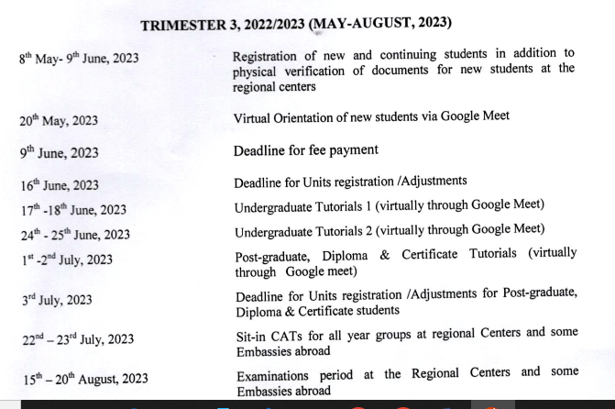
Calendar of Activities For the CEP
